Section 18: Some features associated with deprivation

To return to database home page click here.
Contents of this section
1. Life Expectancy
2. Health
3. Attainment in Education
4. Job Opportunities

Main Points
1. Life Expectancy
2. Health
a) In Scotland’s most deprived areas, the percentage of low birth weight babies is over twice as high as that in the least deprived areas. In 2010, 31 per cent of babies who were born with very low birth weight were born in Scotland to mothers living in the most deprived areas, compared with 13 per cent of babies born to mothers living in the least deprived areas. (Audit Scotland, 2012).

b) children living in the 5% most deprived areas experience significantly worse health outcomes than other children. (Audit Scotland, 2012)

c) In its 2007 UNICEF report card on children’s wellbeing, UNICEF placed the UK at the bottom of 21 developed countries for overall child well-being. The organisation produced its latest report in August 2013: this time covering the 29 most advanced countries in the world. Based on its research, it placed the UK in 16th position, below Slovenia, the Czech Republic and Portugal. To quote from the report: “Worrying findings include high rates of teenage pregnancy, and high numbers of young people out of education, employment and training. The UK has one of the highest alcohol abuse rates among 11-15 year olds, and was placed in the bottom third of the infant mortality league table.

d) A survey of mental health among children in Scotland in 2013 found that inequalities by area deprivation (SIMD) were common across both mental wellbeing and mental health problems. Children and young people living in more deprived areas had, in general, poorer mental health outcomes than those living in less deprived areas. (Source: Scotland’s mental health: Children & young people 2013, Scotpho, NHS Scotland)

e) A report by Audit Scotland in 2011 showed that “Health inequalities are long-standing and entrenched in Scotland. On average, people in Scotland’s poorest neighbourhoods die earlier and children in the most deprived areas have significantly worse health.” Audit Scotland found people in deprived areas have higher rates of coronary heart disease, mental health problems, obesity, alcohol and drug misuse problems, diabetes and some types of cancer. As examples it reports that alcohol-related admissions to hospitals for people from deprived postcodes are seven times higher than for those in affluent areas: twice as many people in deprived areas consult their GP for anxiety related conditions: and 40 per cent of adults in deprived areas smoke, compared with just 11 per cent in affluent areas.

f) Statistics presented by the Information Services Division of NHS Scotland on breast cancer show that the 20% least deprived group in the Scottish population have the highest incidence (136.1) of breast cancer but the lowest mortality (24.5) per 100,000. For the 20% most deprived group, the incidence is lower (117.6), but mortality is at its highest (26.7).
Source: http://www.isdscotland.org/Health-Topics/Cancer/Cancer-Statistics/Breast/

g) Strokes: Rates of cerebrovascular disease mortality vary between areas of greater or less deprivation. There is a clear association between standardised mortality rates (SMR) and deprivation in the under 65 age group, with the SMR in the under 65s being four times higher for the most deprived 10% datazones compared to the least deprived 10% datazones. (Source: ISD, January 2014 release).

3. Education
a) The Scottish Survey of Literacy and Numeracy, released in April 2013, shows that of S2 pupils from the 30% most deprived areas in Scotland only 28% attained the standards of “working well or working very well” in numeracy compared to 56% of pupils from the 30% least deprived areas. The comparable figures for literacy were 75% and 91% respectively. Differences in literacy and numeracy between pupils from different deprivation areas for earlier age groups were also found.

b) The chart below shows the average tariff scores of school leavers in the 20% most deprived areas in Scotland and in the 20% least deprived areas. While there has been an improvement in average tariffs through time, there continues to be a large gap in attainment between those coming from poor areas and those from the least deprived areas. In 2011/12, the average attainment score for children coming from the 20% most deprived areas in Scotland was half that of those children coming from the 20% least deprived areas.

4. Employment and Training among Young People
a) In 2012, the chances of a young person in a deprived area being in neither employment education or training were almost three times as great as in the rest of Scotland. (29.4% of 16 to 19 year olds in the 15% most deprived areas of Scotland were neither in employment, education or training: 10.6% in the rest of Scotland.) (Scottish Government).
b) 35% of all young men (16 to 19 years) in the 15% most deprived areas of Scotland were in neither employment, education, or training compared with 11.6% for young men in other parts of Scotland. The corresponding percentages for young women were 23.9% and 9.6%.

Chart 1: School Leaver Attainment

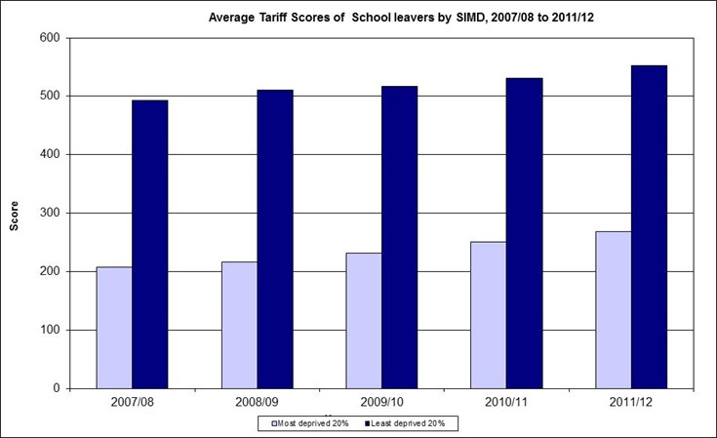
Source: Scottish Government, Pupil Attainment - Average Tariff Scores of School Leavers, June 2013

